All about Blog website name :- [Raju’s blog](https://rajublog.herokuapp.com/blog/)

**Deploy this site on Heroku server link is** : <https://rajublog.herokuapp.com/blog/>

My GitHub Link is : <https://github.com/rajukumar2152>

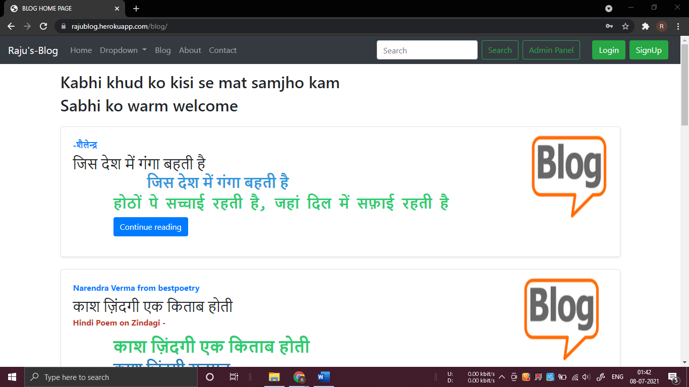

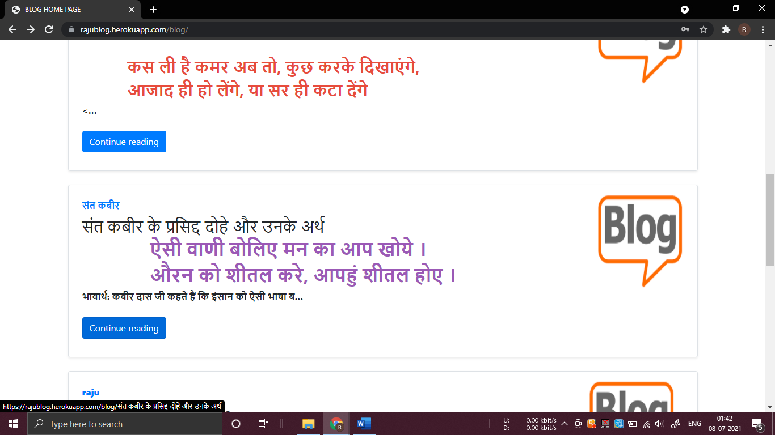

**This is main page of the site here we can find all the blogs there is few detail of the blog . When we click on the continue reading then we get the full article of the blog**

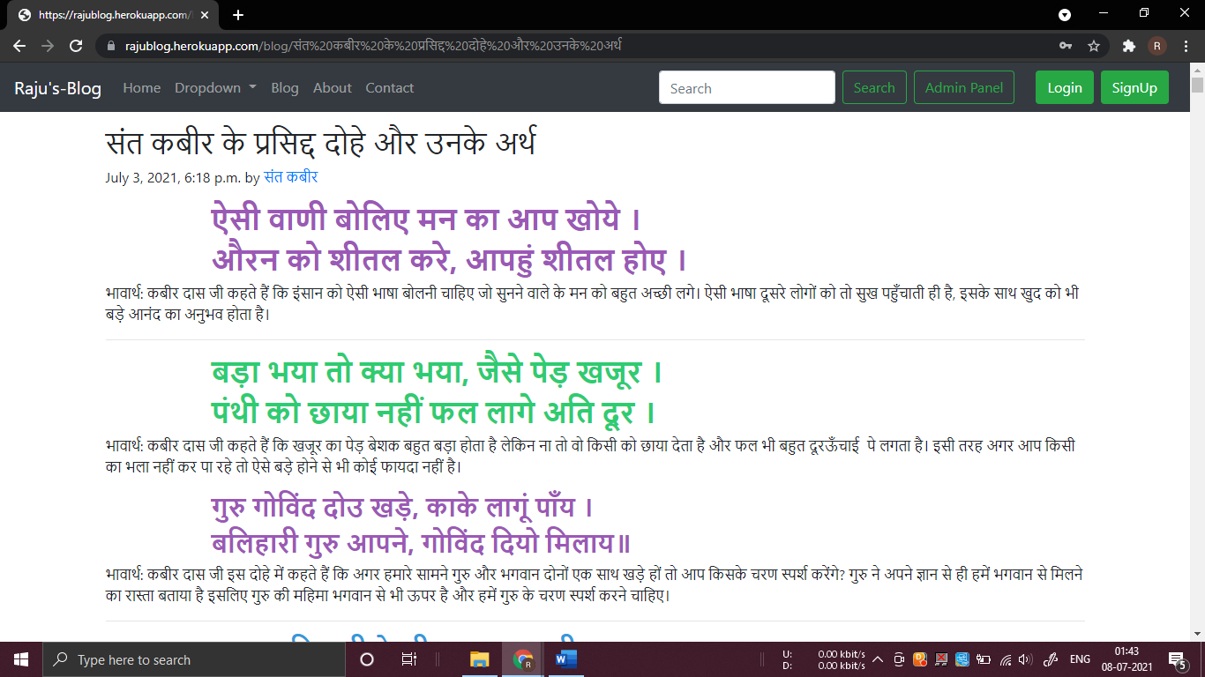

After clicking on the continue to reading button

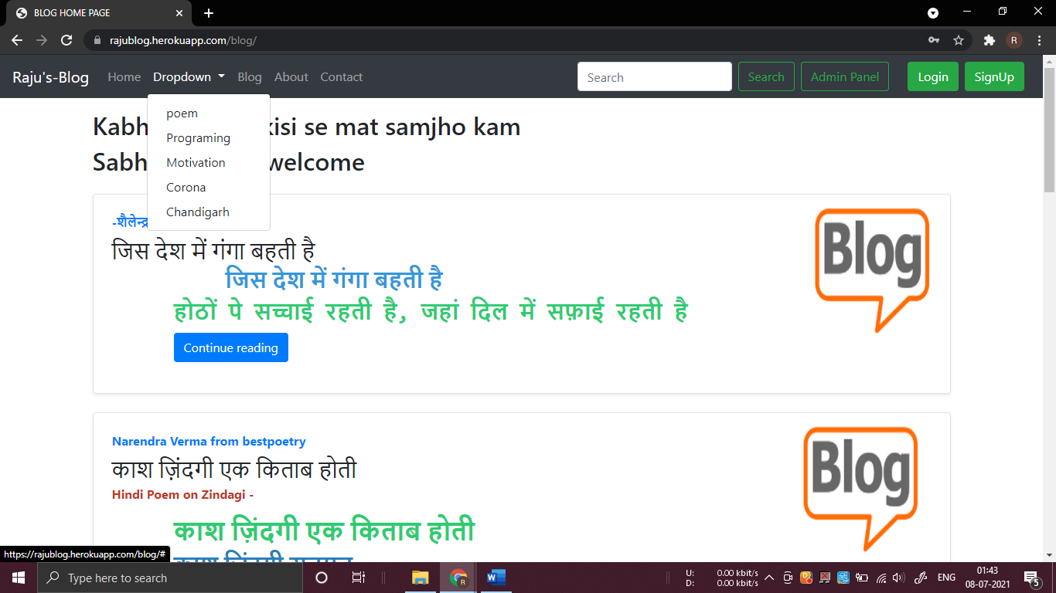

Here we can sort the blogs according to category wise

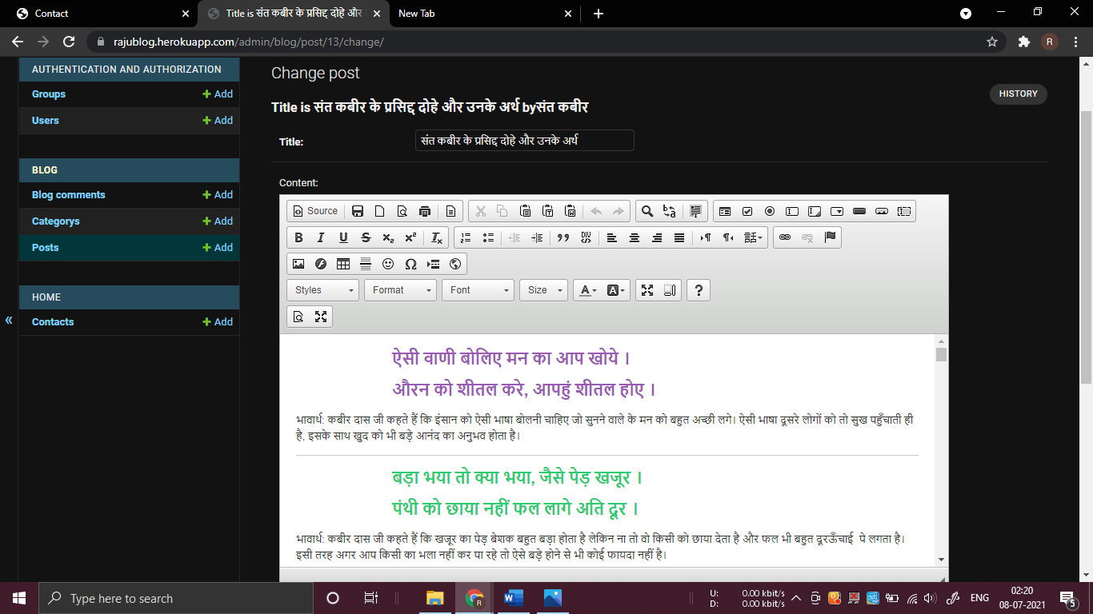

This site is integrated with the CK-editor which make writing a blog life easier .

As easier like as writing in MS-Word

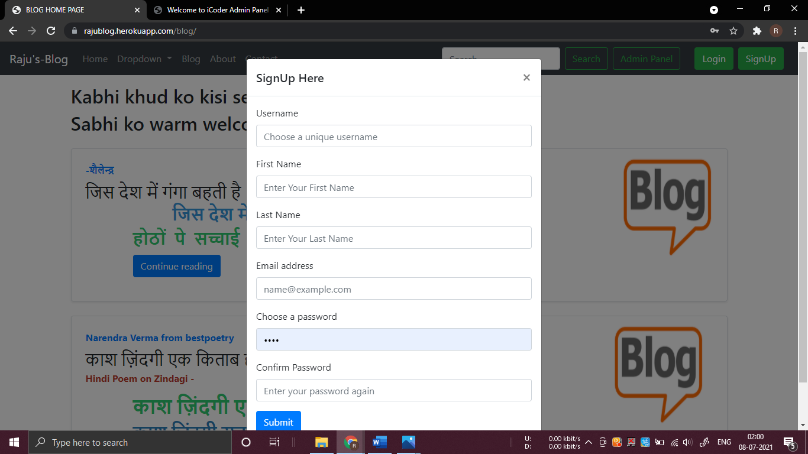

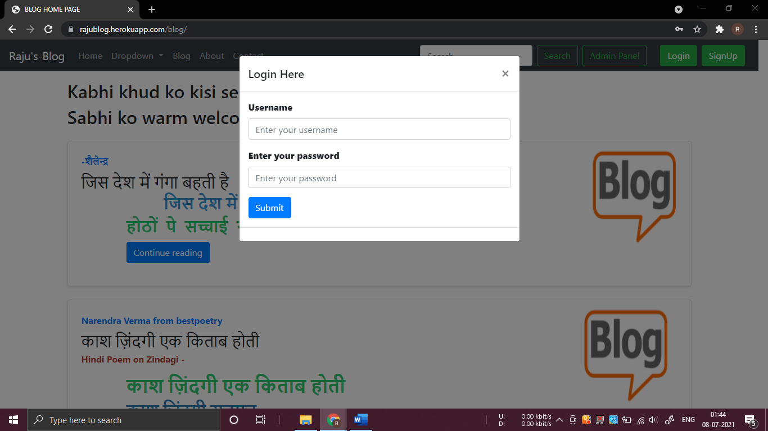

Here user can easily signup and login

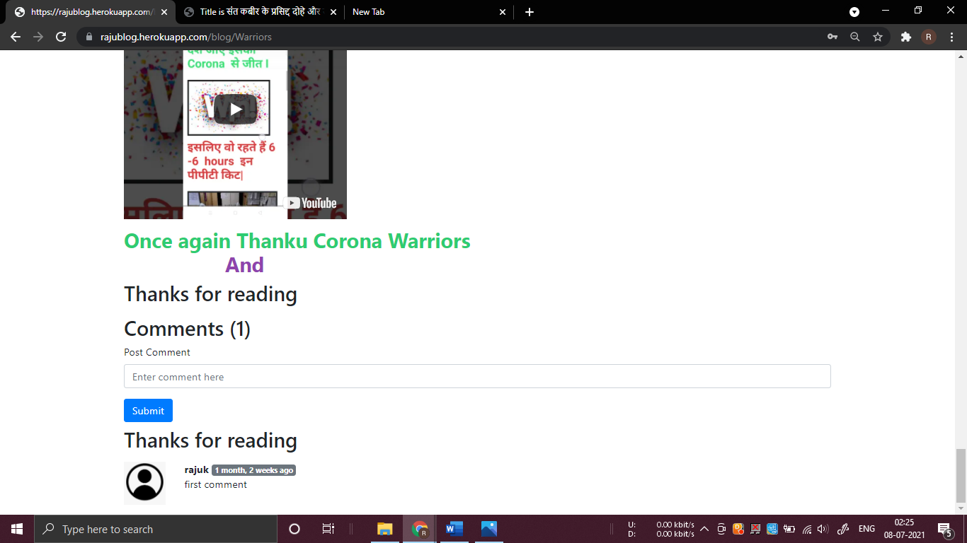

Here authenticated user can also do comment

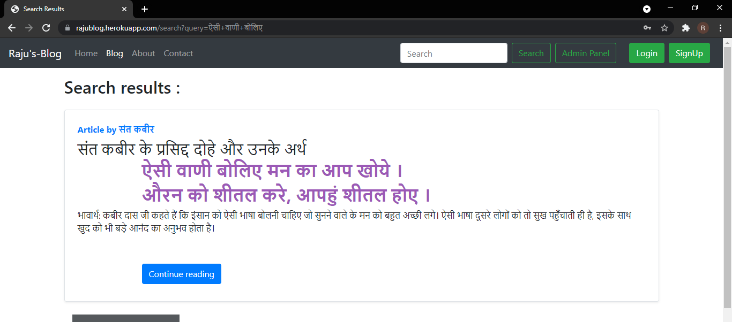

Here user can easily search a result

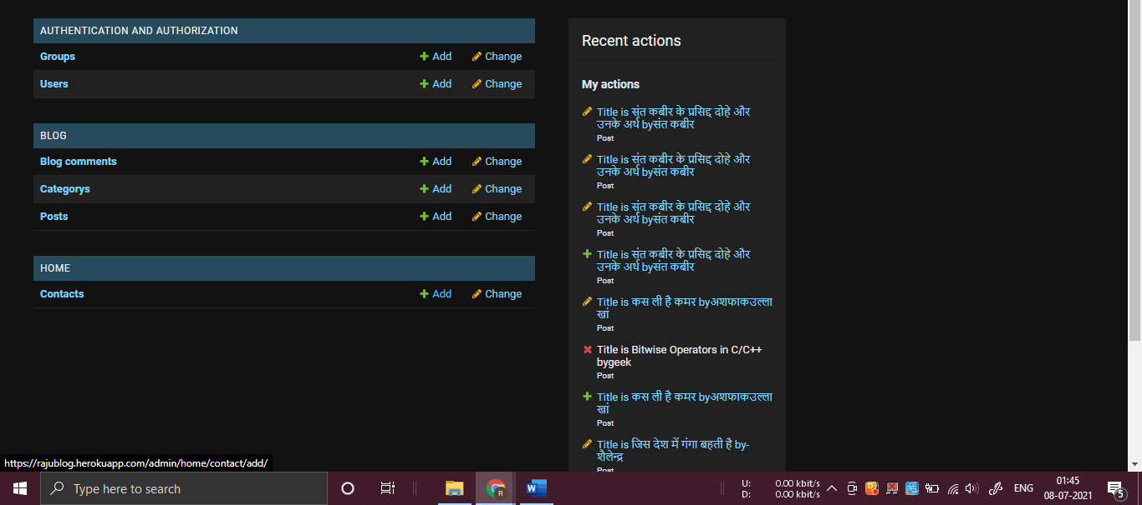

This admin panel and database

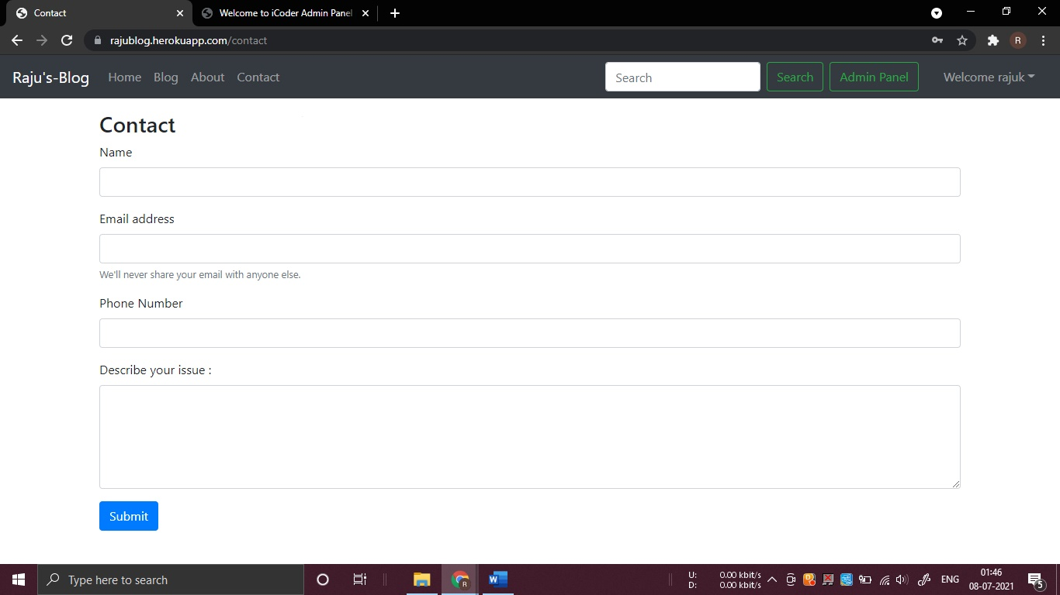

User can easily contact to the admin

This is a full fledge website and it can be use it